Aim: Perform Gray Level Operation Images
Theory:
Gray level operations are image processing techniques used to modify the intensity or brightness values of pixels in a grayscale image. A grayscale image generally contains pixel values ranging from 0 to 255, where 0 represents black and 255 represents white.
Gray level transformations are applied to improve the appearance of an image or to highlight specific features. A general gray level transformation can be represented as: [ s = T(r) ]
where \(r\) is the original pixel intensity, \(s\) is the transformed intensity, and \(T\) is the transformation function.
Some commonly used gray level operations include:
- Image Negative: Reverses the intensity levels, making dark areas bright and bright areas dark.
- Brightness Adjustment: Increases or decreases the intensity of pixels to make an image brighter or darker.
- Thresholding: Converts an image into different intensity regions based on a selected threshold value.
- Contrast Enhancement: Expands or modifies the range of intensity values to make details more visible.
These operations are useful in applications such as image enhancement, object detection, medical imaging, and feature extraction.

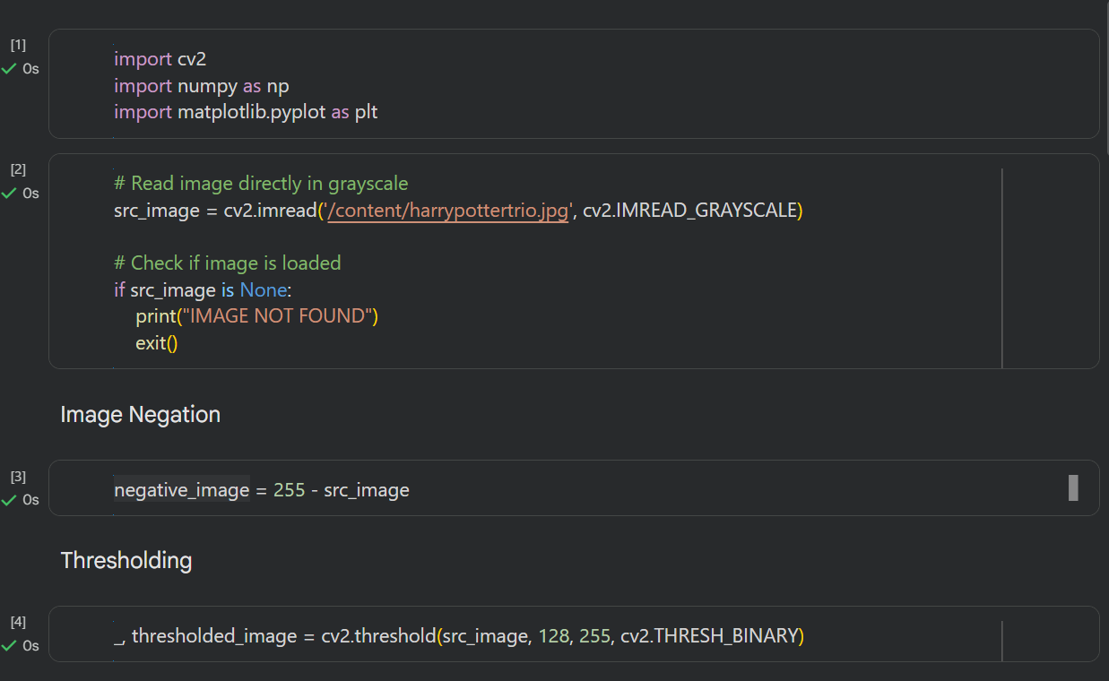
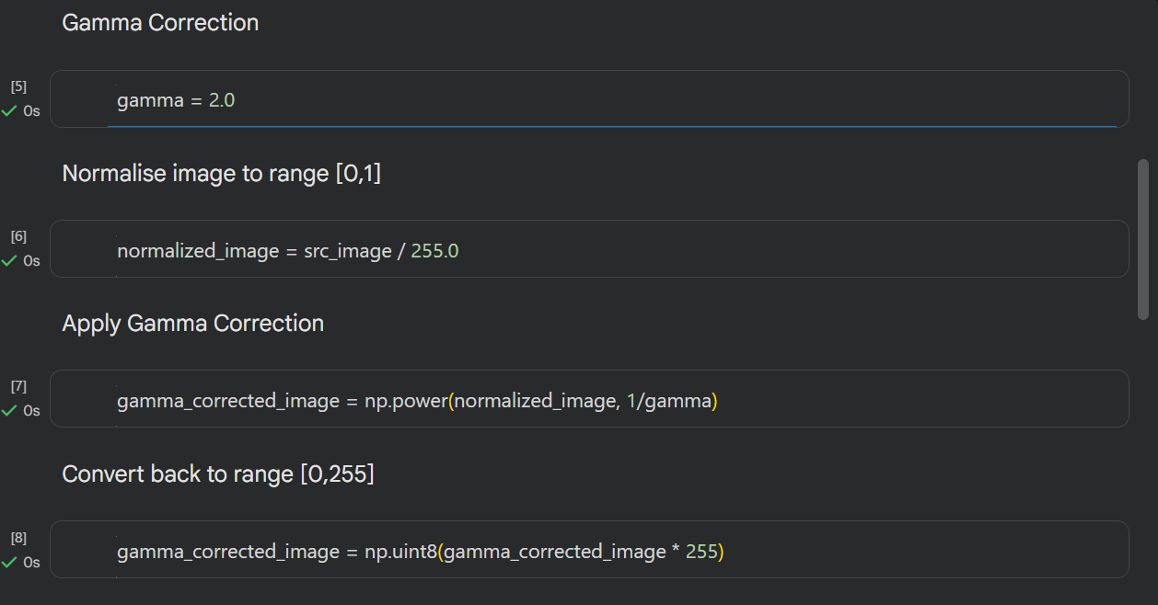
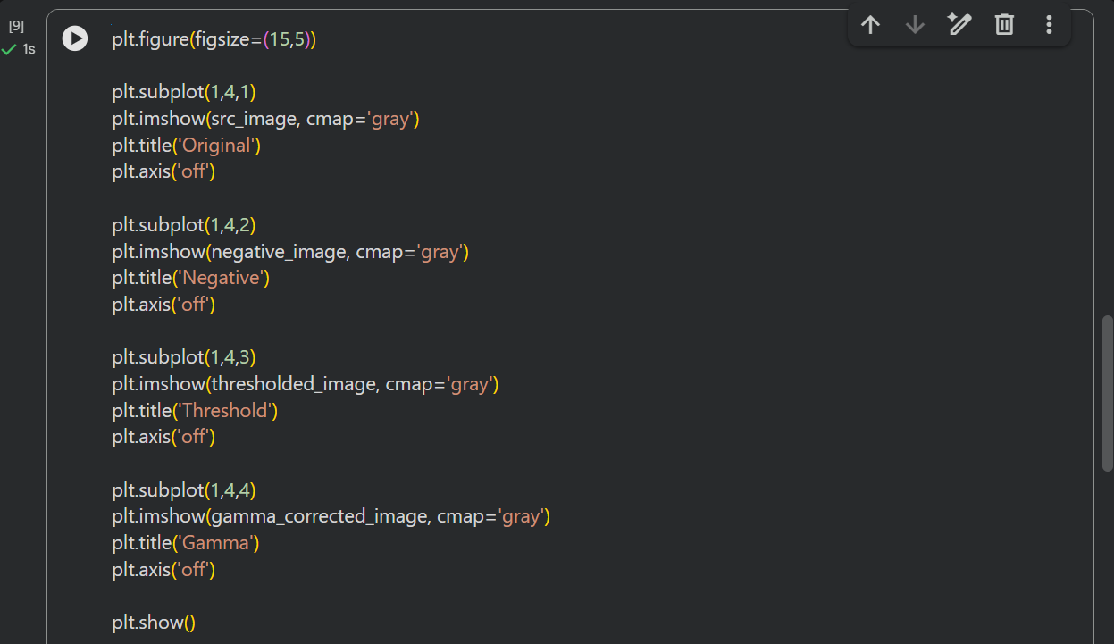
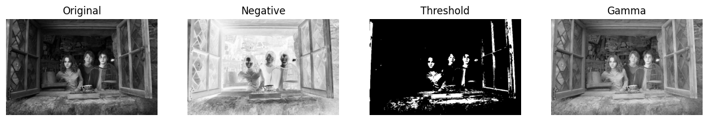
Conclusion:
In this experiment, we studied and performed gray level operations on images. We understood how changing the intensity values of pixels can affect the brightness, contrast, and overall appearance of an image. The experiment helped us understand the basic role of gray level transformations in image enhancement and how they can be used to make important features of an image more visible.
Github Link: https://github.com/divaparekh06/Digital-Signal-And-Image-Processing.git

